|  |  |
| --- | --- |
|  | |
| National Park Service  U.S. Department of the Interior  Natural Resource Stewardship and Science | National Park Service Logo |

Forest Vegetation Monitoring

Mid-Atlantic Network 2007-2021 Status Report

Natural Resource Report NPS/MIDN/NRR—201X/XXXX

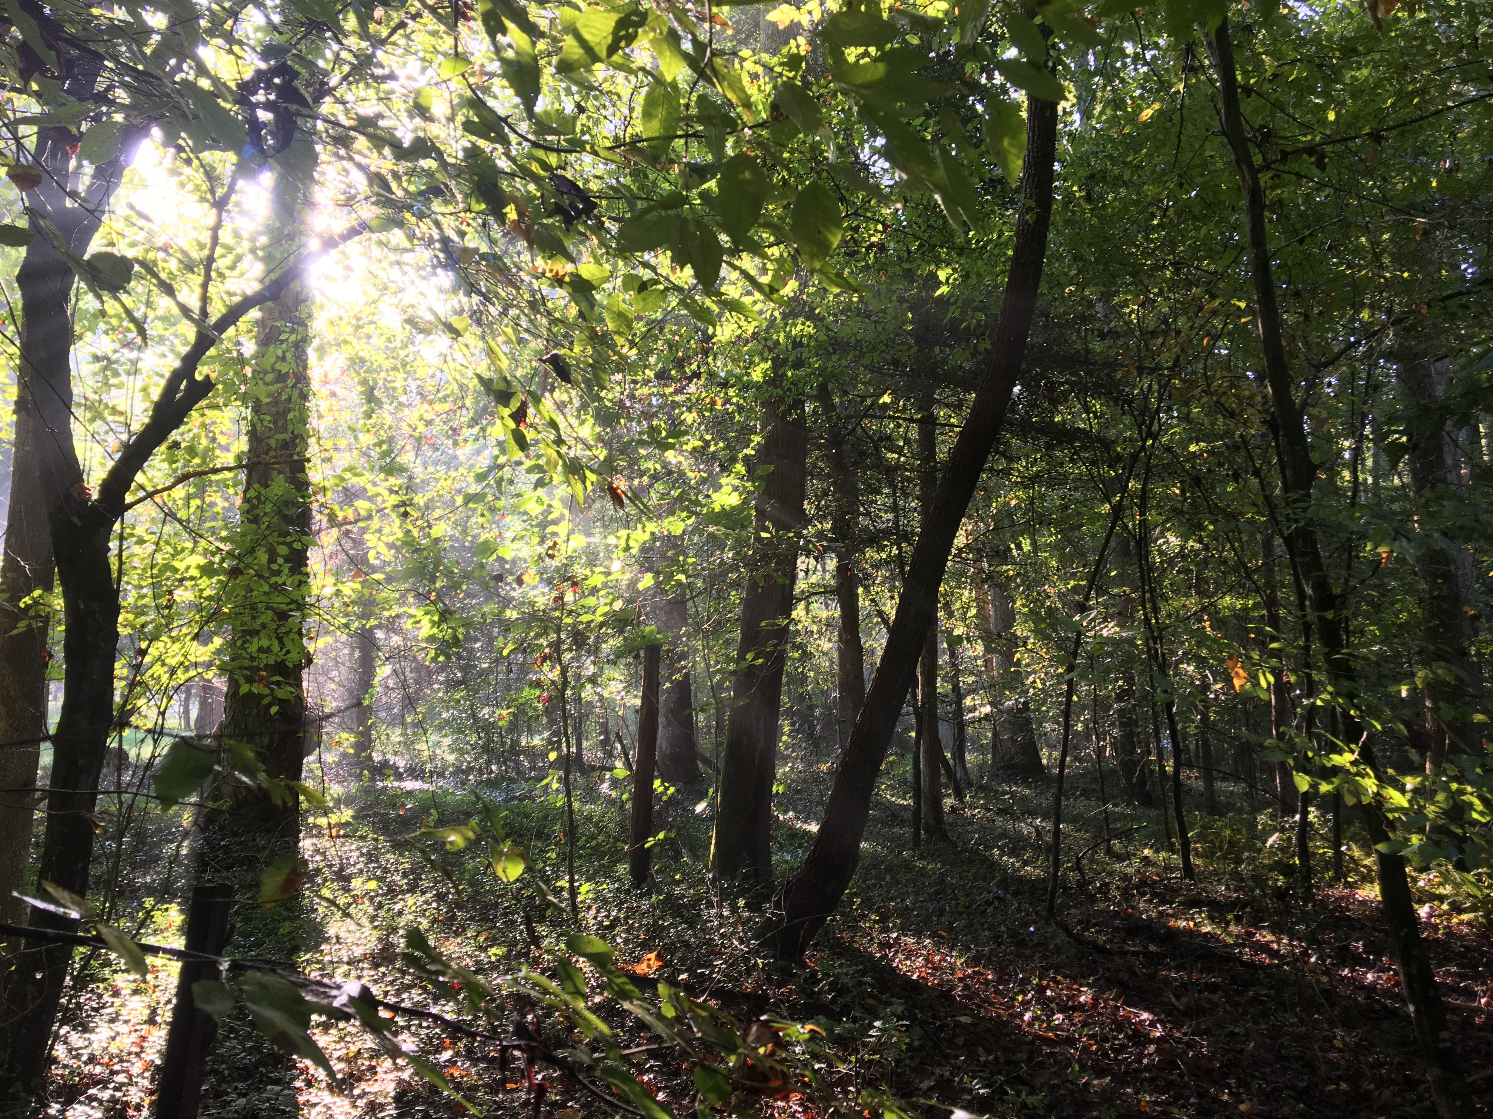

**ON THE COVER**

Forest plot in Richmond National Historical Park

NPS Photo

Forest Vegetation Monitoring

Mid-Atlantic Network 2007-2021 Status Report

Natural Resource Report NPS/MIDN/NRR—201X/XXXX (Style: *nrps Series name/number*)

Author One,1 Author Two,2 Author Three,1 Author Four3

1National Park Service (organization name is mandatory)  
Address Line 1 (address is optional)  
Address Line 2 (address is optional)  
City, State Zip code (city and state are mandatory, Zip code is optional)

2Organization Name (organization name is mandatory)  
Address Line 1 (address is optional)  
Address Line 2 (address is optional)  
City, State Zip code (city and state are mandatory, Zip code is optional)

3Organization Name (organization name is mandatory)  
Address Line 1 (address is optional)  
Address Line 2 (address is optional)  
City, State Zip code (city and state are mandatory, Zip code is optional)

Month Year

U.S. Department of the Interior  
National Park Service  
Natural Resource Stewardship and Science

Fort Collins, Colorado

The National Park Service, Natural Resource Stewardship and Science office in Fort Collins, Colorado, publishes a range of reports that address natural resource topics.These reports are of interest and applicability to a broad audience in the National Park Service and others in natural resource management, including scientists, conservation and environmental constituencies, and the public.

The Natural Resource Report Series is used to disseminate comprehensive information and analysis about natural resources and related topics concerning lands managed by the National Park Service. The series supports the advancement of science, informed decision-making, and the achievement of the National Park Service mission. The series also provides a forum for presenting more lengthy results that may not be accepted by publications with page limitations.

All manuscripts in the series receive the appropriate level of peer review to ensure that the information is scientifically credible, technically accurate, appropriately written for the intended audience, and designed and published in a professional manner.

This report received formal peer review by subject-matter experts who were not directly involved in the collection, analysis, or reporting of the data, and whose background and expertise put them on par technically and scientifically with the authors of the information.

Views, statements, findings, conclusions, recommendations, and data in this report do not necessarily reflect views and policies of the National Park Service, U.S. Department of the Interior. Mention of trade names or commercial products does not constitute endorsement or recommendation for use by the U.S. Government.

NPS XXXXXX, Month 201X

This report is available in digital format from <http://www.nps.gov/im/midn> and the [Natural Resource Publications Management website](http://www.nature.nps.gov/publications/nrpm/). To receive this report in a format that is optimized to be accessible using screen readers for the visually or cognitively impaired, please email [irma@nps.gov](mailto:irma@nps.gov?subject=irma@nps.gov).

Please cite this publication as:

Lastname, A. B., C. Lastname, and D. E. Lastname. 20XX. Full title of report in sentence case: Including subtitle. Natural Resource Report NPS/XXXX/NRR—20XX/XXXX. National Park Service, Fort Collins, Colorado.

Contents

Page

Figures iv

Tables iv

Appendices or Appendixes iv

Executive Summary v

Acknowledgments vi

Introduction 7

Methods 8

Results 8

Discussion 8

Literature Cited 8

Figures

Page

**No table of contents entries found.**

Tables

Page

**No table of contents entries found.**

Appendices or Appendixes

Page

Appendix A 9

Executive Summary

Executive summary here

Acknowledgments

Acknowledgements here

**Introduction**

The Mid-Atlantic region is primarily a forested ecoregion and all Mid-Atlantic Network (MIDN) parks have forests that form an essential part of the landscape and provide habitat for a diversity of wildlife. For this reason, the vital signs selection process highlighted forest vegetation and several associated indicators as being a high priority for monitoring (Comiskey et al. 2009). The network thus initiated forest monitoring in 2007, conducting an initial year of pilot plot implementation which helped refine the process for the subsequent establishment of additional monitoring plots between 2008 and 2010. Four Northeast Coastal and Barrier Network (NCBN) parks were incorporated, three in 2008 and one in 2011 (Table 1). The full forest vegetation monitoring protocol was finalized and published in 2009 (Comiskey et al. 2009). In 2013, plots established in 2009 were revisited for the first time. The third year of plot establishment was conducted in 2013 at Colonial National Historical Park, with an additional 12 plots to be established in 2014.

The overarching goal of the vegetation monitoring program is to provide a framework for monitoring long-term change over broad spatial scales of the forests in the parks. The monitoring protocol calls for establishment of a network of vegetation plots across eight of the 10 MIDN parks (Shenandoah NP uses a separate protocol (Cass et al. 2011), and forest cover is low at Eisenhower NHS), and four NCBN parks (Figure 1).

Specific monitoring objectives include:

* Determine the status and trends in forest structure, composition, and dynamics of canopy and understory woody species.
* Determine the status and trends in the density and composition of tree seedlings and selected herbaceous species that are indicators of deer browse.
* Detect and monitor the presence of invasive exotic plants, exotic plant diseases and pathogens, and forest pests.
* Determine the status and trends in forest coarse woody debris and the availability of snags.
* Determine the status and trends in soil Ca:Al and C:N ratios to assess the extent of base caution depletion, increased aluminum availability and/or nitrogen saturation impacting MIDN forest soils.

This report focuses on a subset of the data collected between 2011 and 2013 (census 2) and is compared to the same plots established between 2007 and 2009 (census 1). Inferences are made on a park basis, but comparisons for Fredericksburg and Spotsylvania NMP, Petersburg NB, and Colonial NHP analyses and summary statistics are reported for individual units within the parks. Table 1 shows the allocation of plots in relation to forest area in the MIDN and NCBN parks.

Methods

Methods here

1. List 1
2. List 2
3. List 3

Results

Results here

Discussion

Discussion here

Literature Cited

Comiskey, J. A., J. P. Schmit, and G. Tierney. 2009. Mid-Atlantic Network forest vegetation monitoring protocol. Natural Resource Report NPS/MIDN/NRR—2009/119 National Park Service, Fort Collins, Colorado.

Appendix A

Appendix here

The Department of the Interior protects and manages the nation’s natural resources and cultural heritage; provides scientific and other information about those resources; and honors its special responsibilities to American Indians, Alaska Natives, and affiliated Island Communities.

NPS XXXXXX, Month Year (The Fort Collins Support Office will fill out this line for you)

|  |  |
| --- | --- |
|  | |
| National Park Service  U.S. Department of the Interior | National Park Service Logo |

[**Natural Resource Stewardship and Science**](https://www.nps.gov/orgs/1778/)

1201 Oakridge Drive, Suite 150  
Fort Collins, CO 80525

EXPERIENCE YOUR AMERICA TM